***Dt : 10/5/2022***

***"Scanner" class:***

***=>"Scanner" is a Pre-Defined class from java.util package and***

***which provide pre-defined methods to read data into Java program.***

***=>The following are some important pre-defined methods from***

***'Scanner' class:***

***1.nextByte()***

***2.nextShort()***

***3.nextInt()***

***4.nextLong()***

***5.nextFloat()***

***6.nextDouble()***

***7.nextBoolean()***

***8.nextLine()***

***=>These are NonStatic methods and will get the memory within the***

***object and can be accessed with object_name.***

***=>The following is the syntax of creating object for 'Scanner'***

***class:***

***syntax:***

***Scanner s = new Scanner(System.in);***

***=>'System.in' in Java represent connecting OS-Buffer to Scanner***

***Class object.***

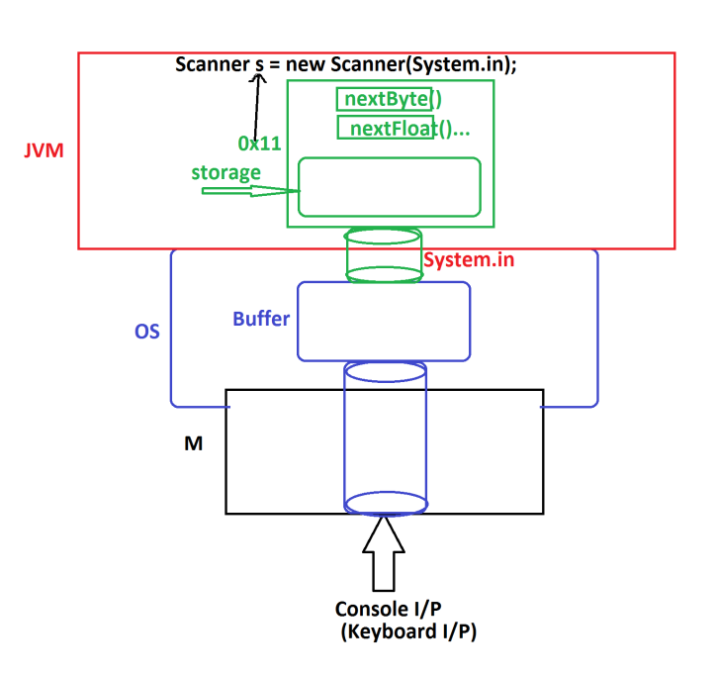

***1.nextByte():***

***=>This method is used to read byte value.***

***Method Signature:***

***public byte nextByte();***

***syntax:***

***byte b = s.nextByte();***

***2.nextShort():***

***=>This method is used to read short value.***

***Method Signature:***

***public short nextShort();***

***syntax:***

***short sh = s.nextShort();***

***3.nextInt():***

***=>This method is used to read int value.***

***Method Signature:***

***public int nextInt();***

***syntax:***

***int i = s.nextInt();***

***4.nextLong():***

***=>This method is used to read long value.***

***Method Signature:***

***public long nextLong();***

***syntax:***

***long l = s.nextLong();***

***5.nextFloat():***

***=>This method is used to read float value.***

***Method Signature:***

***public float nextFloat();***

***syntax:***

***float f = s.nextFloat();***

***6.nextDouble():***

***=>This method is used to read double value.***

***Method Signature:***

***public double nextDouble();***

***syntax:***

***double d = s.nextDouble();***

***7.nextBoolean():***

***=>This method is used to read boolean value.***

***Method Signature:***

***public boolean nextBoolean();***

***syntax:***

***boolean bl = s.nextBoolean();***

***8.nextLine():***

***=>This method is used to read string value.***

***Method Signature:***

***public String nextLine();***

***syntax:***

***String str = s.nextLine();***

***========================================================***

***Ex_Program:***

***wap to read and display User details like name,mailid and phno?***

***Program : DemoUser.java***

***package p1;***

***import java.util.Scanner;***

***public class DemoUser***

***{***

***public static void main(String[] args)***

***{***

***Scanner s = new Scanner(System.in);***

***System.out.println("Enter the username:");***

***String name = s.nextLine();***

***System.out.println("Enter the MailId:");***

***String mId = s.nextLine();***

***System.out.println("Enter the phoneNo:");***

***long phNo = s.nextLong();***

***System.out.println("====UserDetails====");***

***System.out.println("UserName:"+name);***

***System.out.println("MailId:"+mId);***

***System.out.println("PhoneNo:"+phNo);***

***s.close();***

***}***

***}***

***o/p:***

***Enter the username:***

***nit.v***

***Enter the MailId:***

***v@gmail.com***

***Enter the phoneNo:***

***9898981234***

***====UserDetails====***

***UserName:nit.v***

***MailId:v@gmail.com***

***PhoneNo:9898981234***

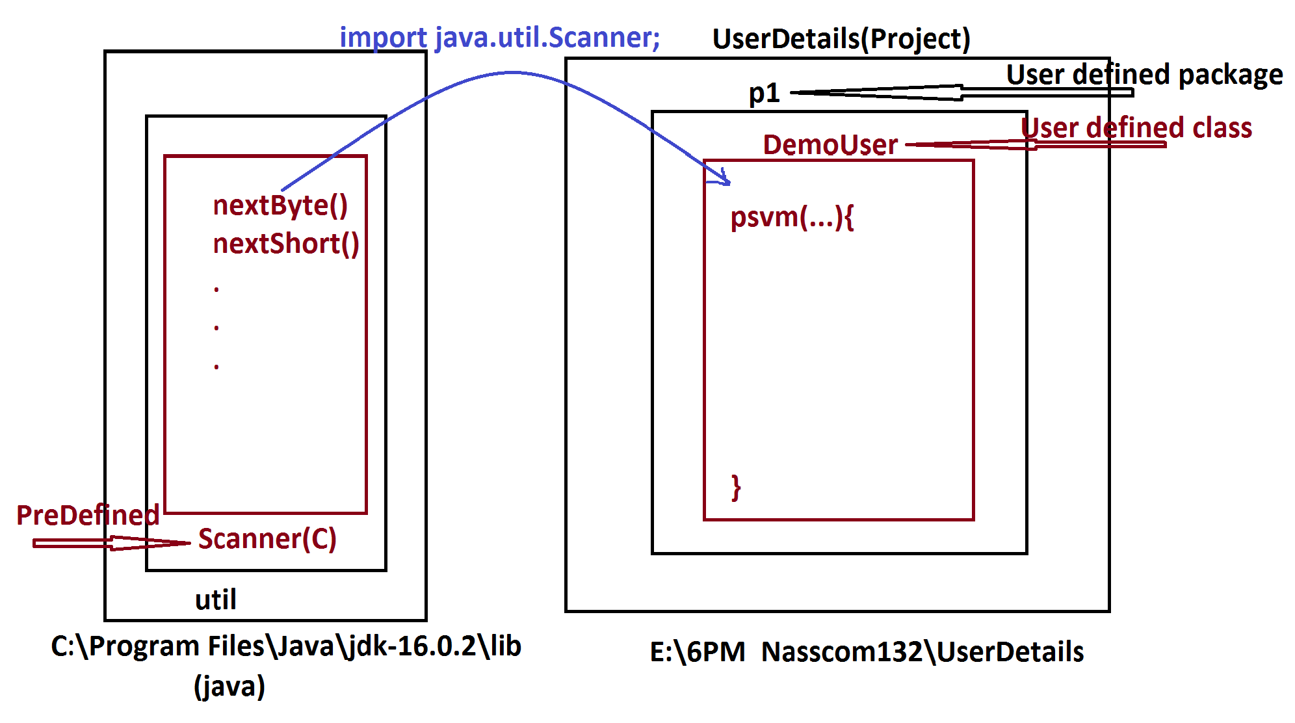

***===========================================================***

***Assignment:***

***Update StudentResult program by reading six subject marks from***

***Console(Keyboard)?***

***===========================================================***